 **GO-STANDARD NURSERY & PRI-SCHOOL**

**END OF YEAR EXAMINATION 2023**

**PRIMARY TWO**

**MATHEMATICS**

**My name is ___________________________________________**

**I am in ________________________________________________**

**My school is __________________________________________**

**SECTION : A. (40 MARKS).**

1. **Subtract / Take away**.

a) 7 - 7 = b) 14 - 6 =

c) 3 4 c) 2 4

- 1 0 - 1 6

2. **Circle the greatest number**.

a) 09 , 19 , 90 b) 46 , 16 , 32

c) 101 , 121 , 110

3. **Write in words.**

a) 35 = _________________________ b)100_________________________

4. Set A = { 2, 4, 6, 8}

B = {3, 4, 5, 6}

a) **How many members are in set B**?

_______________________________________________________________

b) **List the members which are shared by set A and B**.

A ∩ B = _____________________________________

5. **Add:**

a) 12 + 4 = b) 8 + 4 + 3 =

c) 4 d) 5 3

+ 3 + 2 7

6. **Find the expanded number**.

a) 50 + 6 = b) 600 + 9 =

7. **Write the place value of the circled number**.

a) 2 3 b) 4 5 c) 3 6 4

**SECTION : B (60 Marks)**

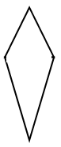

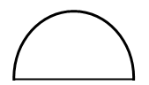8. **Name these shapes**.

a) b

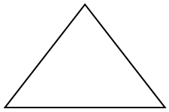

c)

9. **Divide /Share.**

a) 15 ÷ 3 = b) 6 ÷ 3 =



c)

10. **Draw tens and ones**

a) 30 = b) 5 =

c) 22 =

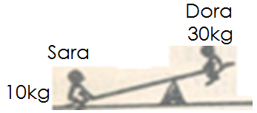11. **Compare the weight**.

a) Who is heavier?

__________________________________________________________________

b) Who is lighter?

__________________________________________________________________

12. **Multiply/ Tables.**

a) 8 x 2 = b) 3 c) 5 d) 3 2

x 4 x 3 x 3

13. **Find the missing number**.

a) + 3 = 13 b) - 5 = 12

c) x 3 = 15 d) 12 ÷ = 4

14. How many days make a week?

__________________________________________________________________

15. **Use >, <, or = to complete correctly**.

a) 4 + 4 ____________ 4 x 2

b) 08 _____________ 80

c) 51 ______________ 15

d) 2weeks ______________ 14 days.

16. **Study the homework time table for P.2 and answer the questions that follow.**

|  |  |  |  |  |
| --- | --- | --- | --- | --- |
| **Monday** | **Tuesday** | **Wednesday** | **Thursday** | **Friday** |
| Tables | English | Number | Literacy 1A | Number |

a) How many subjects were taken home that week?

__________________________________________________________________

b) Which subject was taken on Thursday?

__________________________________________________________________

c) Which subject was taken twice in that week?

__________________________________________________________________

d) When was English taken?

__________________________________________________________________

e) _________________________________ was the first subject to be taken home that week.

17. What is a subset?

__________________________________________________________________

